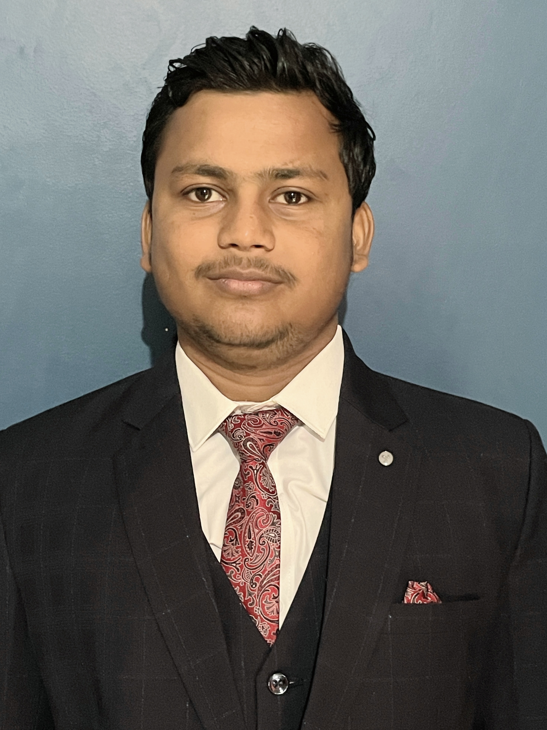
Sachin Kumar Mehta
Contact Information:
  - Email: sachinkm1011@gmail.com
  - Phone: 8709164981
  - Address: Bhubaneswar, Odisha
  - LinkedIn: Sachin Mehta

About Me:
Motivated and skilled software engineering fresher with a strong foundation in programming languages, algorithms, and software development methodologies. Eager to leverage academic knowledge and internship experience to contribute effectively to a dynamic software development team.

Education
Kalinga Institute of Industrial Technology, Bhubaneswar
B.Tech. in Computer Science and Engineering (2021–2025) CGPA: 7.53 O.P. Jindal School, Patratu, Ramgarh, Jharkhand
Intermediate (12th) (2019–2021) Percentage:84.8% DAV Public School, Patratu, Ramgarh, Jharkhand
Matriculation (10th) (2007–2019) Percentage: 84.0%
Skills Acquired:
- Programming Languages:
  - C Programming
  - C++ Programming
  - Python
  - HTML
- Other Skills:
  - Data Structures

Projects:
- Sign-Language-To-Speech
  - Technologies: Python, TensorFlow, Keras, NumPy, OpenCV, pyttsx3
  - Developed a real-time sign language translation model focusing on finger spelling gestures using machine learning and computer vision techniques
Co-Curricular Activities:
- Participated as a delegate in World Bank in KIIT MUN.
- Participated in an event organized by IOT Lab KIIT.
- Social Service (donated blood at a blood donation drive organized by Kalinga Institute of Medical Science).

Certificates:
- Problem Solving Skills (Basic) - HackerRank, Online
- Problem Solving Skills (Intermediate) - HackerRank, Online

